**“Helping Each Other Grow”**

**ANTI-BULLYING PLAN 2025** 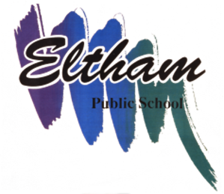

***Eltham Public School***

Bullying behaviour has three key features. It involves the intentional misuse of power in a relationship. It is ongoing and repeated, and it involves behaviours that can cause harm. The NSW Department of Education requires all NSW public schools to have an Anti-bullying Plan which details the strategies implemented to reduce student bullying behaviours.

**Resources**

The NSW anti-bullying website (see: <https://education.nsw.gov.au/>) provides evidence-based resources and information for schools, parents and carers, and students. Schools are encouraged to visit the website to support whole-school prevention, early intervention and response approaches and strategies for student bullying behaviour.

**Eltham Public School’s commitment**

Our school rejects all forms of bullying behaviours, including online (or cyber) bullying by maintaining a commitment to providing a safe, inclusive and respectful learning community that promotes student wellbeing. Staff are committed to establishing evidence-based approaches and strategies that promote a positive climate where bullying is less likely to occur. A key component of a supportive school culture is building respectful relationships and an ethos that bullying is not accepted, in both online and offline environments. School staff actively respond to student bullying behaviour.

The five evidence-based elements; Leadership, Inclusion, Student voice, Partnerships and Support, based on the [Australian Student Wellbeing Framework](https://studentwellbeinghub.edu.au/educators/framework/) are used to implement a planned whole-school approach to promote student safety and wellbeing and effectively address bullying behaviour.

Eltham’s approach to counter bullying is both preventative and responsive. Our preventative approaches aim to stop bullying from occurring in the first place, and our responsive approaches include steps taken to resolve the issue after bullying has occurred as well as to prevent bullying behaviours from occurring again in the future.

Eltham Public School provides a caring environment where every student feels safe and respected as an individual. Bullying of any kind is not acceptable at Eltham. NO ONE HAS THE RIGHT TO BULLY ANOTHER PERSON and NO ONE HAS TO TOLERATE BULLYING.

**Definition of Bullying**

Bullying is a pattern of behaviour by one person or group towards another or others, which is intended to hurt, injure, embarrass, threaten, upset or cause discomfort. The behaviour is intentional, repeated, selected and uninvited. Bullying involves the abuse of power in relationships.

Bullying can be:

**Physical** Punching, hitting, pushing, tripping, taking people’s things.

**Verbal** Name calling, demanding money or goods, using threatening words and put downs.

**Social** Alienating, shutting people out of groups, ignoring others, making rude gestures, spreading rumours and gossip.

**Psychological** Spreading rumours, stalking, dirty looks, hiding or damaging possessions, passing notes, stares and whispers etc.

**A casual occurrence or a sudden flare up or fight between peers is not necessarily bullying.**

**Relationship and Friendship difficulties are also not regarded as bullying.**

**Purpose of this Document**

* To maintain a commitment to provide a safe and supportive environment for all students.
* To provide a clear procedure to deal with bullying.
* To provide members of the school community, students, and staff with the knowledge of what constitutes bullying.

**Procedures for Dealing with Bullying Behaviour**

Eltham Public School has a no tolerance approach to bullying behaviour. All incidents of inappropriate behaviour reported to a teacher by students or members of the school community or observed by a teacher in the playground will be acted upon immediately. Any incident will be discussed at weekly Learning and Support Team meetings. Any student or students involved will be identified and strategies to support individual needs will be implemented. All parents of children involved in any incidents will be contacted by the principal.

**Reporting Bullying Behaviour**

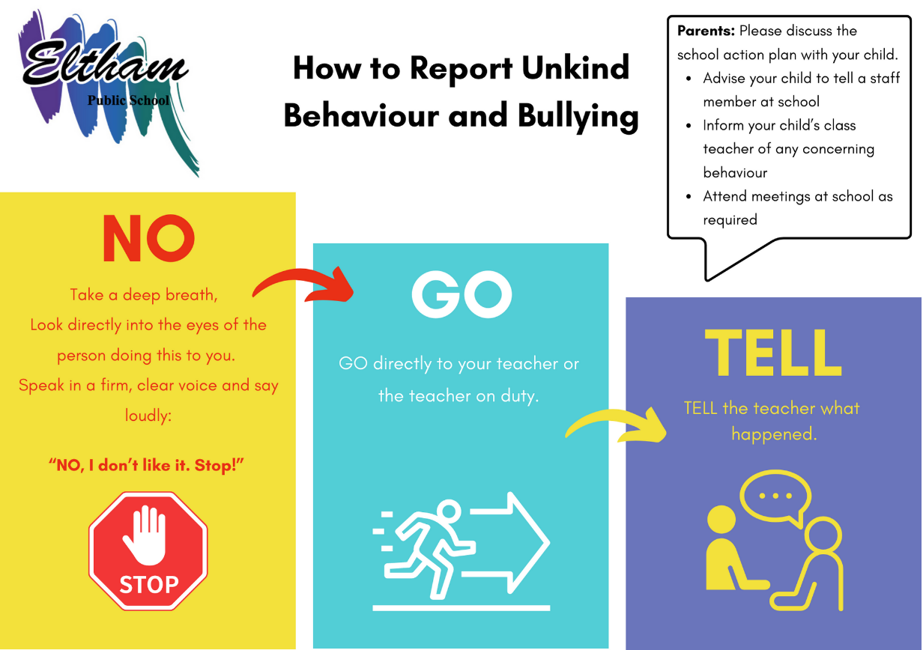

The ‘How to Report Unkind Behaviour and Bullying’ action plan is communicated to every school family in the newsletter and a laminated glossy action plan with magnet is given to every family, and new families to put on the fridge at home. There is a poster of the action plan in every classroom and numerous around the school playground.

Students are explicitly taught how to use the action plan in every classroom, at the beginning and throughout each term.

**Staff:** Acting on and reporting incidents as soon as they happen and implementing appropriate strategies. All incidents are to be recorded in Sentral, including detailed follow up actions.

**1 School culture and inclusion**

All members of the school community are active participants in building a welcoming school culture that values diversity and fosters positive relationships. A key component of a supportive school culture is building respectful relationships and an ethos that bullying is not accepted, in both online and offline environments. School staff will ALWAYS respond to student bullying behaviour.

Our school engages in the following practices to promote a positive school culture.

* 1. **Student assemblies**

Student bullying and expectations about student behaviour will be discussed and information presented to promote a positive school culture where bullying is not accepted.

|  |  |
| --- | --- |
| Dates | Communication topics |
| Every Term | [Behaviour Code for Students](https://education.nsw.gov.au/content/dam/main-education/policy-library/associated-documents/pd-2006-0316-01.pdf#:~:text=expected%20to%3A&text=Not%20bully%2C%20harass%2C%20intimidate%20or,high%20quality%20teaching%20and%20learning.) |
| Daily at ‘Crunch n Sip’ | The Three R’s - Respectful, Responsible and Resilient |
| Weekly | Reminders and discussion within classroom about being respectful and kind to others |
| Annually (August) | National Day of Action Against Bullying |

* 1. **Staff communication and professional learning**

Staff will be supported with professional learning that provides evidence-based ways to encourage and teach positive social and emotional wellbeing and discourage, prevent, identify, and respond effectively to student bullying behaviour.

|  |  |
| --- | --- |
| Dates | Communication topics |
| Daily | Professional dialogue and communication relating to student wellbeing and relationships. Teaching and reinforcing respectful relationships with students, teachers, and parents. |
| As required | Respectful relationships reinforced through outside agencies and PDHPE courses. |
| Yearly | Child Protection Training for all staff. |
| Yearly | Child Protection units taught to students K-6. |
| Weekly,  Ongoing | School Partnership Program – The Resilience Project. |

* 1. **New and Casual Staff**

New and casual staff will be informed about our school’s approaches and strategies to prevent and respond to student bullying behaviour in the following ways.

New and casual staff are given the school policy and procedures documents and information (Anti-bullying policy and School Behaviour Support and Management Plan) in a handout when they enter on duty at the school. The principal speaks to new and casual staff when they enter on duty at school, as part of the induction process.

1. **Partnerships with families and community**

Effective schools have high levels of parental and community involvement. This involvement is strongly related to improved student learning, attendance and behaviour. Our school proactively builds collaborative relationships with families and communities to create a shared understanding of how to support student learning, safety and wellbeing.

* 1. **Website**

Our school website has information to support families help their children to regulate their emotions and behaviour and develop socially. Information is provided to assist if children have been involved in bullying behaviour (as the person engaging in bullying behaviour, as the person being bullied or as the person witnessing the bullying behaviour). The following are published on our school’s website:

* School Behaviour Support and Management Plan
* School Anti-bullying Plan
* NSW Anti-bullying website
* Behaviour Code for Students
* School Community Charter
  1. **Communication with Parents**

Our school will provide information to parents to help promote a positive school culture where bullying is not acceptable and to increase parent’s understanding of how our school addresses all forms of bullying behaviour.

|  |  |
| --- | --- |
| Dates | Communication topics |
| As required | Parent meetings |
| Ongoing | School website communication |
| Annually | P & C Meetings, Bullying awareness session – Defining student bullying and school supports, Kindergarten information sessions, Participation and newsletter communication on National Day of Action Against Bullying |
| Monthly | Information contributing to providing a positive school culture around Bullying, building resilience in students is regularly communicated in the newsletter |
| Ongoing | The Resilience Project website, webinars and newsletter articles |

1. **Support for wellbeing and positive behaviours**

Our school’s practices support student wellbeing and positive behaviour approaches that align with our school community’s needs. Social and emotional skills related to personal safety, resilience, help-seeking and protective behaviours are explicitly taught across the curriculum in Personal Development, Health and Physical Education (PDHPE). Examples of other ways our school will embed student wellbeing and positive behaviour approaches and strategies in practices include the following:

* Teaching and reinforcing respectful relationships in anti-bullying days, structured PDHPE, Child Protection and Anti-Bullying lessons.
* Individual education and behaviour plans to develop strategies for positive peer relations.

In 2023, Eltham Public School joined The School Partnership Program with The Resilience Project (TRP). This program supports the wellbeing of the whole school community and builds a positive school culture. TRP is committed to teaching positive mental health strategies to prevent mental ill health and build young people’s capacity to deal with adversity. Through an evidence-based Teaching and Learning Program and inspiring digital presentations for student, staff and parents/carers, the school partnership program aims to support mental health in the classroom, staff room and family home.

Completed by: Jakeb Currie, Helen Gray, Janet O’Shannessy, Chelsea Elliott and Hannah Watson

Positions: Teaching Principal, Assistant Principal Curriculum and Instruction and Classroom Teachers.

Last review date: SDD 3, Term 1, 2025

Next review date: SDD 3, Term1, 2026